Alg 4 Summer Name: ____________________________

______________ _____________

WS Assessment

Target 11:

Percentile

**I can:**

* Explore of normal models for single peaked symmetric data.
* Based on the normal curves, I can make predictions for the percentiles various subjects fall into.

**Unit 9: Statistic**

[**HSS.ID.A.4**](http://www.corestandards.org/Math/Content/HSS/ID/A/4/) Use the mean and standard deviation of a data set to fit it to a normal distribution and to estimate population percentages. Recognize that there are data sets for which such a procedure is not appropriate. Use calculators, spreadsheets, and tables to estimate areas under the normal curve.

The ACT is a nationally-administered test that colleges use to help make admissions decisions for potential students. Nationwide, the scores are normally distributed, with a mean score of 21 (**out of a possible 36**) and a standard deviation of 4.7 Sketch the normal model of the scores.

Adèle scored 25 on the ACT. Let’s explore how well she did. Remember your normal curve is a model for the bars of a histogram. Shade the area under the normal curve for all the scores below

Adèle’s score. Show me the graph as you draw for stamp

The percentage of area on the normal curve called Percentile. Re-find Adèle percentile using normaldist(mean, stdev).cdf(?,?)= ?

What was Rémy’s percentile if he scored 16 on the ACT?

Show me for stamp (both ways)

Mike got 99th percentile on this ACT, what is his score?

Graph the intersection of normaldist(mean, stdev).cdf(x) and y = .99

You will get _____ score on this ACT, what is your percentile? Now you want to be on top of 85th percentile, what score should it be? Show me for stamp

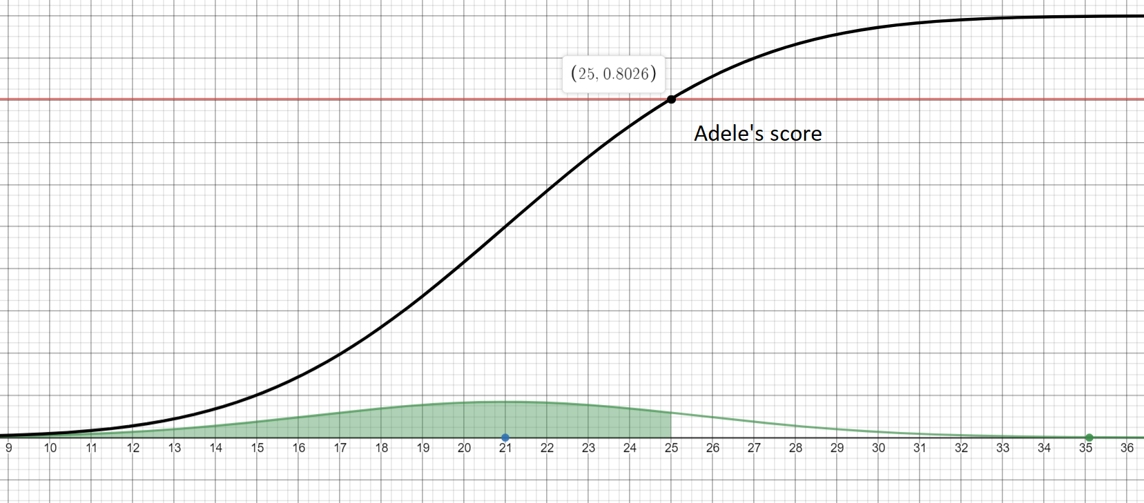

Find the percentage of students whose score from 16 to 22 points both ways (graph and function). Do you get 44%? Sketch it here. Stamp

Find the area under the curve for the following normal distribution (Show me for stamp)

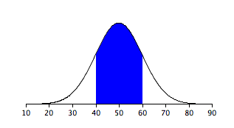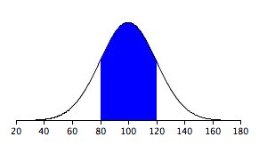

Sketch and find the area under the standard normal curve that lies between

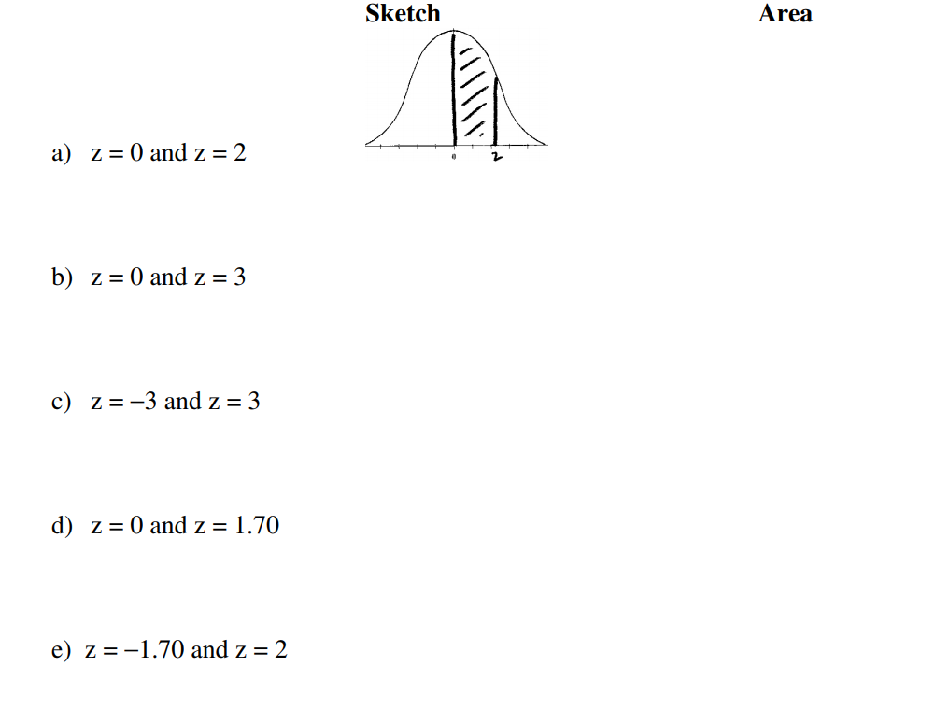

Sketch and find the area under the standard normal curve that lies between

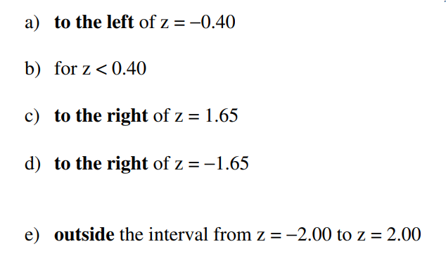

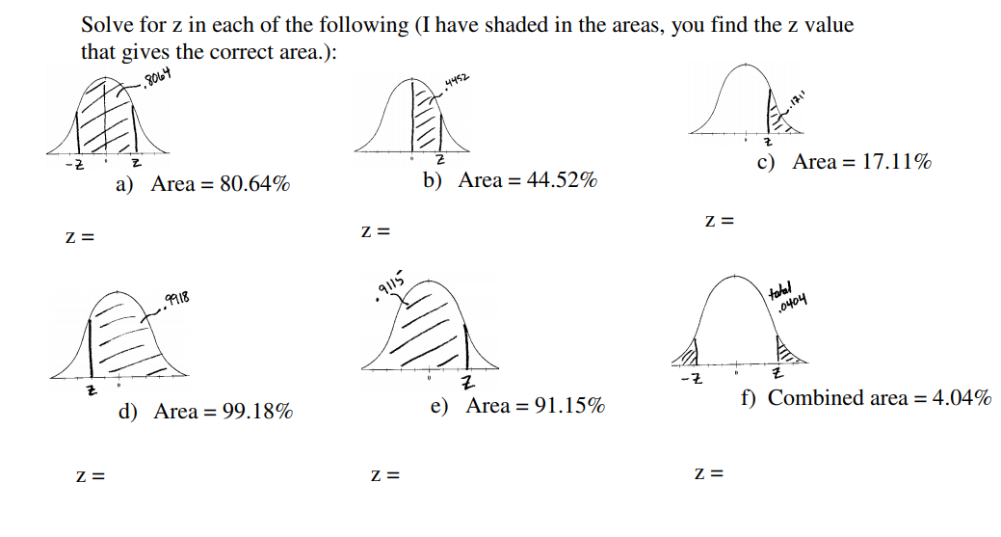

Show me problem **d, e** and **f** for stamp

**Percentiles** are defined as the values that divide the whole series into 100 equal parts.

The **percentile rank** of a particular score is defined as the percentage of individuals in the distribution with scores at or below the particular value. The score is called percentile when a score is identified by its percentile rank.

B = number of scores below x  
E = number of scores equal to x (can be zero if no equal)  
n = number of scores.

The scores are 21, 24, 26, 27, 28, 28, 31, 32, 34, 36, 39, 40, 42, 44, 45, 46, 49, 53, 57, 60.

Find out the percentile rank for score 28.

n = ? ______ B = ? ______ E = ? _______

Percentile = ? __________

The scores for student are   
40, 41, 42, 43, 45, 47, 49, 50, 51, 51, 54, 57, 59, 60, 61, 63, 67, 69, 70, 71. Find out the percentile rank for score 51.

Find the percentile rank of score **93** on this list 48, 52, 58, 64, 70, 74, 79, 84, 89, 93, 96, 97, 100.

If Jason graduated 25th out of a class of 150 students, what Jason's percentile rank would be

**Given percentile, find the score, using the formula $L=\frac{k}{100}×n$**

where n number of items in a series, The kth percentile are given by its locator L

Given the scores for student are

40, 41, 42, 43, 45, 47, 49, 50, 51, 51, 54, 57, 59, 60, 61, 63, 67, 69, 70, 71.

Find the score at 25th percentile 50th percentile 75th percentile

Find the score at 16th percentile 67th percentile 78th percentile

Percentile vs. Percentage

- A percentage score indicates the proportion of a test that someone has completed correctly.

- A percentile score tells us what percent of other scores are less than the data point we are investigating.

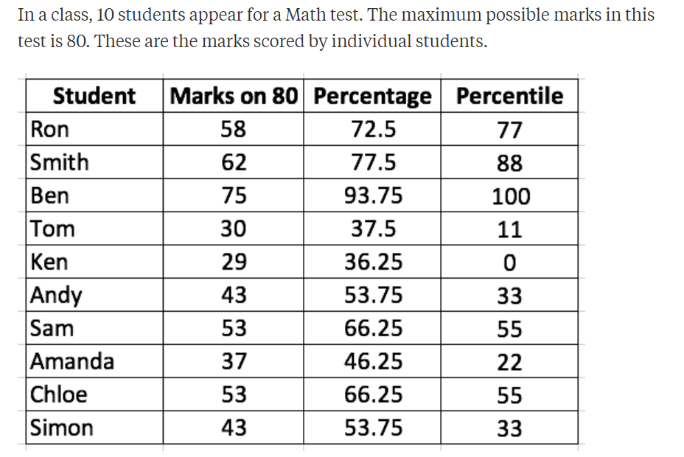

Explain the scoring of Ron

**Target 11 Assessment**

**I can…** find the percentile and apply it in real life problem

1. Back to the scoring table in the Target, explain Chloe’s score, does she “pass” the test.

2. The math test scores were:

50, 65, 70, 72, 72, 78, 80, 82, 84, 84, 85, 86, 88, 88, 90, 94, 96, 98, 98, 99. Find the percentile rank for if you score of 84 on this test.

For this same test above, if someone is at _____ percentile, what his/her score would be?

64% 75% 86%

3. U.S. men have an average height of 69.3 inches with a standard deviation of 2.8 inches.

Mike is 75 inches, what is his percentile top? Show work

If Tom is in the 99th percentile, how tall is Tom? Show work

4. The length of human pregnancies from conception to birth varies according to a distribution that is approximately normal with mean 266 days and standard deviation 16 days.

Draw and label a distribution that shows percent of pregnancies last between 250 and 282 days? Stamp

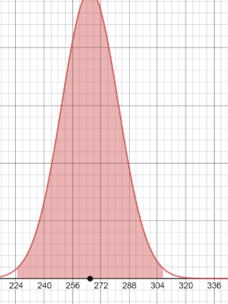

A pregnancy located in the 16th percentile would last how long?

We know roughly 99% of all pregnancies fall **between** how many days?

Stamp